Patent Search:

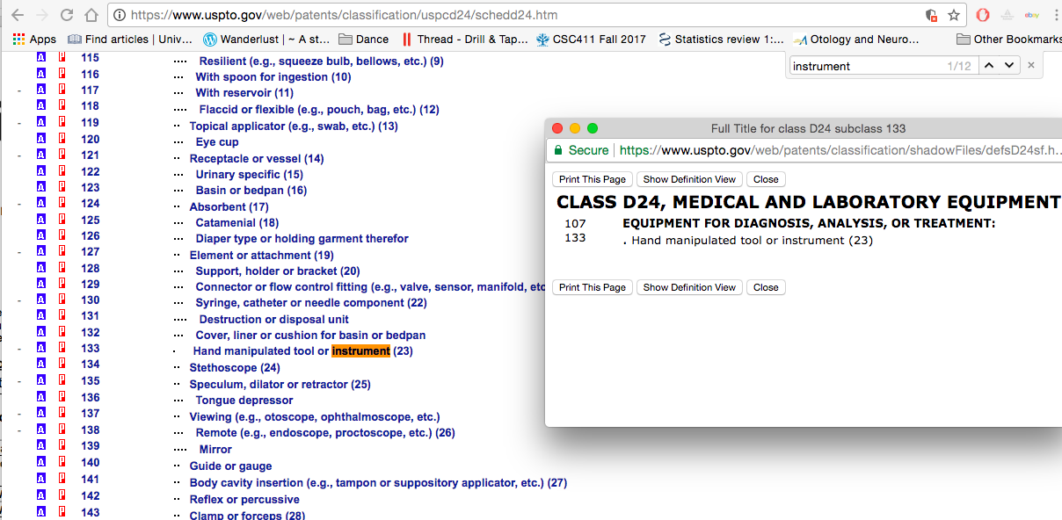

Classes:

|  |  |
| --- | --- |
| **CLASS D24, MEDICAL AND LABORATORY EQUIPMENT** | |
| 107 | **EQUIPMENT FOR DIAGNOSIS, ANALYSIS, OR TREATMENT:** |

|  |  |
| --- | --- |
| 133 | . Hand manipulated tool or instrument (23) |

Click on the “p” button beside the class

<http://patft.uspto.gov/netacgi/nph-Parser?Sect1=PTO2&p=1&u=%2Fnetahtml%2Fsearch-bool.html&r=0&f=S&l=50&TERM1=D24%2F133&FIELD1=ORCL&d=pall>